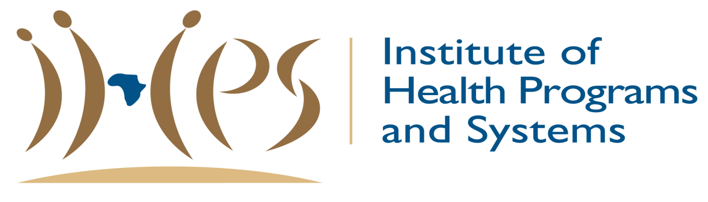

Request for Applications
Terms of Reference (TOR)
Prevention Programs for Adolescent Girls and Young Women Global Fund Grant 1 April 2019 – 31 March 2022
Ref: RFA- IHPS-AGYW-MBO- 2019
Closing Date: 12 November 2019, 17h00

PLEASE NOTE: Changes made to this RFA and all relevant documents will be posted on IHPS’s website: www.ihps-sa.org
Table of Contents

Abbreviations ……………………………………………………………page 3-4
Introduction and Background ………………………………………….page 5
Role of Sub Sub-Recipient …………………………………………….page 6
Scope of work……………………………………………………………page 7
Modalities………………………………………………………………...page 7
Modality 1: Quantile 1-3 School based interventions ………………. page 7-8
Small Advocacy grant overview……………………………………….page 9
Outputs Target: Prevention Programs………………………………...page 10-11
Resources Allocation …………………………………………………...page 12
Evaluation Process and Criteria………………………………………..page 13
Key Dates…………………………………………………………………page 14
Contact Details…………………………………………………………..page 14

ABBREVIATIONS

AGYW Adolescent Girls and Young Women
AFSA AIDS Foundation of South Africa
AIDS Acquired Immune Deficiency Syndrome
ART Anti-Retroviral Therapy
B-BBEE Broad- Based Black Economic Empowerment
CCM Country Coordinating Mechanism
CSE Comprehensive Sexuality Education
DOH Department of Health
GBV Gender Based Violence
GFATM The Global Fund to Fight AIDS, Tuberculosis and Malaria
GP General Practitioner
HTS HIV Testing Services
HIV Human Immunodeficiency Virus
HIVSS HIV Self Screening
IHPS Institute of Health Programs and Systems
IEC Information, Education, Communication
KP Key Populations
LFA Local Fund Agent
M&E Monitoring and Evaluation
MSP Male Sexual Partners
MSM Men who have sex with Men
NSP National Strategic Plan
PCA Provincial Council for AIDS
PEP Post-Exposure Prophylaxis
PHP Primary Health Care
PR Principal Recipient
PrEP Pre-Exposure Prophylaxis
QA Quality Assurance
RFA Request for Application
SA South Africa
SAPS South African Police Services
SAW Social Auxiliary Worker
SGB School Governing Body
SMT School Management Teams
SR Sub-Recipient
SSR Sub Sub-Recipient
SW Sex Worker
TB Tuberculosis
TG Transgender
TVET Technical, Vocational, Education and Training
TOR Terms of Reference

- INTRODUCTION AND BACKGROUND

The South Africa Global Fund Country Coordinating Mechanism (GF CCM) is responsible for leading the implementation of HIV and TB programmes funded by the Global Fund to Fight AIDS, TB and Malaria (GF) in the country.

The GF CCM determines the content of the programming, the budget envelope, and the output and outcome indicators and targets.

The GF CCM has selected the AIDS Foundation of South Africa (AFSA) to be appointed by the GF as one of the Principal Recipients (PRs) that will implement programmes to be funded by the grant. AFSA in turn selected the Institute of Health Programs and Systems (IHPS) as Sub-Recipient. The GF CCM decided that a PR should serve as a grants manager while Sub-Recipient (SRs) will be the main implementers of the programmes. In turn, SRs are expected to collaborate with Sub Sub-Recipient (SSRs) to strengthen program implementation in the districts and sub-districts.

Subsequently, IHPS invites interested non-profit organisations and community-based organizations (CBO) experienced in the program area listed under the scope of work, who MUST be from Mbombela Subdistrict, to apply and be considered as SSRs. It is important to note that SSRs are recommended by the SR, but appointment is subject to AFSA approval. Applicants are not required to submit implementation plans and budgets as part of this request for applications.

- THE ROLE OF SUB-RECIPIENTS

IHPS (SR) has received permission from AFSA (PR) to advertise the Request for Applications for the implementation of the Prevention Programs for Adolescent Girls and Young Women (AGYW) with specific focus on the AGYW In-school Program. The program will be implemented in Mbombela Sub-district, Ehlanzeni District, Mpumalanga Province, as part of the new Global Fund Program (April 2019 – March 2022).

2.1 The Responsibilities of SSR include the following:
- Implement grants under the oversight of the SR, PR and GF CCM and take responsibility for their performance where applicable.
- Propose changes to the SR on work plans and budgets when necessary.
- Participate in performance review meetings to improve grant performance and impact.
- Report on programme progress and challenges to the SR through regular reports.
- Identify key issues and implementations bottleneck and escalate to the SR for guidance.

  - Organisational requirements
The minimum requirements to serve as an SSR include:
- Sound governance frameworks, demonstrated by, inter alia, by a diversified board and management team, and at least one year audited financial statements.
- Appropriate staffing in key areas (programme and financial management, human resources, programme implementation and management, monitoring and evaluation (M&E) and procurement management).
- Experience of managing grants.
- A track record of effective and efficient implementation of similar activities, preferably in the target district.
- A sound system of management and financial controls.
- A sound M&E system, tools and procedures amongst other requirements.
- Suitably qualified personnel to deliver the programme interventions.
These organisational requirements will be assessed during the evaluation process.
- SCOPE OF WORK

3.1 Background
South Africa is home to the largest HIV epidemic in the world, modelled at 7.2 million people living with HIV (PLHIV) (all ages) in 2017. Survey data from the same year show HIV prevalence of 14% among people of all ages (up from 12.2% in 2012), and 20.6% among those aged 15-49 years (up from
18.8% in 2012). Women face disproportionate HIV burden throughout the life cycle, but this gender disparity is most pronounced among adolescent girls and young women (AGYW) aged 15-24 years, whose HIV prevalence is 3.3 times greater than their male peers (15.5% compared to 4.8%) (See Figure 1). South Africa’s epidemiological profile shows that while new infections do occur in adolescent girls below 15 years, incidence is substantially higher in the 15-24 age group. Further, the vast majority (92, 4%) of AGYW have their sexual debut at 15 or older.

Figure 1 HIV Prevalence in South Africa, Disaggregated by Age and Sex (2017)
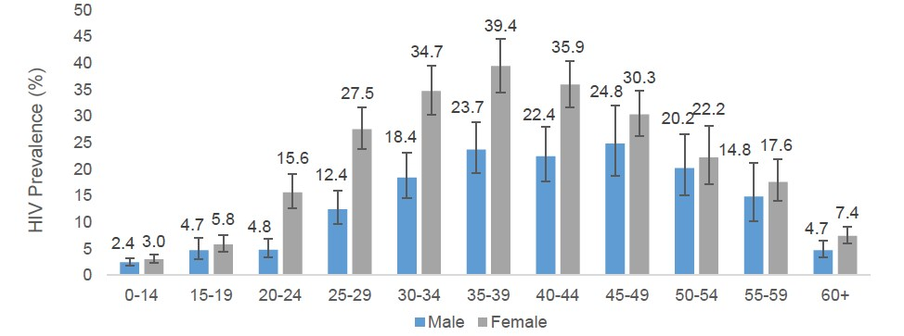

AGYW are the most critical to South Africa’s epidemic. It is estimated that a third of all new HIV infections in the country occur in AGYW age 15-24 years– 1,674 each week.vi Modelling suggests that HIV incidence peaks among AGYW when they are 19 years old, at 2.74% (See Figure 2). However, the age and gender disparity in new infections is greatest among 17- year-olds, when girls are 8.7 times more likely to acquire HIV than their male peers. This data suggests that tailored interventions which focus on older adolescent girls are particularly needed.

Figure 2 HIV Incidence among Adolescents and Young People in South Africa (2017)
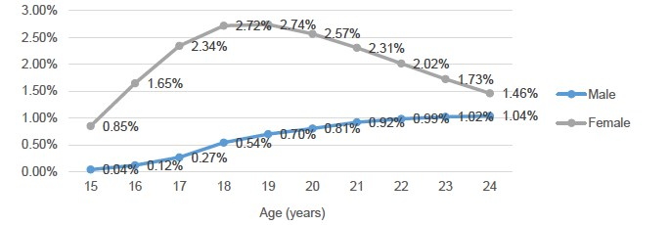

3.2 Objectives
The Global Fund AGYW Programme offers a comprehensive package of services that aim to improve her health, psychosocial and socio-economic wellbeing. The programme targets AGYW, in and out of school, age 15-24 years, with the aim to effect risk reduction, behaviour change and empowerment.
Objectives of the AGYW programme are aligned to She Conquers Campaign and aim to:
- Decrease HIV incidence
- Decrease teenage pregnancy
- Increase retention in schools
- Increase economic opportunities
- Reduce gender-based violence (GBV)

  - AGYW In-school Program Overview
AGYW Program Modality 1: Quantile 1-3 School based Interventions
The programme seeks to:
- Strengthen the capacity of schools to support learners academically, emotionally, socially and physically so that they remain in school until the completion of Grade 12. This will be done through a Whole School Development Approach for the 30 participating schools in Mbombela Sub-district.
- Target learners with a combination package of services because of heightened risk to HIV infection, teenage pregnancy and school drop-out. The primary beneficiaries are girls in grades 8 – 11, and whilst adolescent girls are the target, boys will not be excluded from any School Based Programmes at the 30 participating schools per district.

School Based Programmes
A combination package of age appropriate services will be provided to approximately 30 under resourced public schools (in Quantile 1-3) in each sub-district. The primary beneficiaries are girls in Grades 8 – 11, and boys will not be excluded from any school-based interventions. The grant seeks to target secondary/ combination schools per sub-district. AGYW entering the Programme will be provided with the following core service:
- HIV and gender-based violence (GBV) risk screening
- Offered and HIV test
- Offered condoms
- HIV, SRH and GBV information

The School Based Programme will offer the following services:
Component | Description
The School-based programme will be supported with the following services

Behavioral and  Structural interventions | - Peer education, through the MTV Shuga series, supplemented by content on GBV, substance abuse and HIV related topics.  - Homework and academic support, through after school programmes  - Home visits in cases of prolonged absenteeism  - Career jamborees for Grade 9 learners  - Provision of menstrual dignity packs for girls in need
The School-based programme will be supported with the following afterschool services

Health care services | - HTS, STI and TB screening, contraceptives and condom distribution, pregnancy testing and emergency contraceptives. Where permissible mobile health services will be available on the school premises, but this service will be extended and available via outreach services to other community spaces and also extend to using fixed facilities including PHC clinics, the Safe Space, community health centres and hospitals. Linkage for learners needing PrEP, ART, VL monitoring, PMTCT, TB preventive therapy, STI treatment, TB treatment, TOP, PEP, mental health services.  - Delivery of programmes to support behavioral change and provide psychosocial support: This will include; individual and group psychosocial support, risk reduction interventions like PrEP demand creation and intimate partner violence (IPV) counselling, supportive interventions like teen parenting and parenting programme, and adherence programmes. Such services will be offered on the school premises after school, or at outreach sites or at the Safe Space.
Provision of dignity packs | Situational Analysis to advice of appropriate timing for delivery of menstrual hygiene and self-management education at identified quantile 1-3 schools within the selected sub districts. Identified learners shall receive dignity packs on a monthly basis for the grant period.

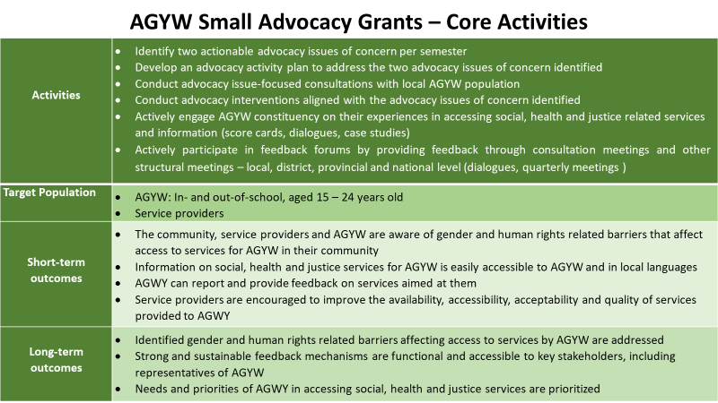

Output Targets: Prevention Programs for adolescents, youth in schools and out of school

Indicator: Percentage of adolescent girls and young women (AGYW) reached with HIV prevention programs- defined package of services

District | Sub-Districts | Year 1 | Year 2 | Year 3
MP Ehlanzeni District  Municipality | Mbombela Local  Municipality | 6741 | 9437 | 10785

Indicator: Number of adolescent girls and young women (AGYW) who were tested for HIV and received their results during the reporting period

District | Sub-Districts | Year 1 | Year 2 | Year 3
MP Ehlanzeni District  Municipality | Mbombela Local  Municipality | 24267 | 26963 | 29659

Indicator: Percentage of adolescent girls and young women (AGYW) using PrEP

District | Sub-Districts | Year 1 | Year 2 | Year 3
MP Ehlanzeni District  Municipality | Mbombela Local  Municipality | 73 | 425 | 728

Indicator: Percentage of AGYW who receive economic strengthening based on an agreed package
District | Sub-Districts | Year 1 | Year 2 | Year 3
MP Ehlanzeni District  Municipality | Mbombela Local Municipality | 1162 | 1768 | 2121

Disclaimer: Note that the targets may be subject to revision and change.

4. Resource Allocation per Sub-District

SSR Organogram

5. EVALUATION PROCESS AND CRITERIA

The evaluation of submissions will be managed by an SSR Selection Panel which will prepare a shortlist of applicants that meet the threshold for appointment as an SSR. The SR will use the shortlist drawn by the selection panel to recommend applicants to be appointed as an SSR by the PR.

The evaluation process will be conducted according to the following stages:
- The first stage of the evaluation process assesses for compliance with pre-qualification criteria. Applications that do not comply will not be evaluated further.
- The second stage of the evaluation process assesses compliance with administrative requirements. Applications that do not comply will not be evaluated further.
- The third stage of the evaluation process assesses technical competency focusing on the ability to fulfil the requirements of an SSR, experience and expertise of implementing similar interventions and presence in the selected district. Applicants need to achieve a score of at least 50 points of the technical competency requirements in order to progress further.
- The fourth stage, which is optional and at the discretion of the Selection Panel, may involve an on-site visit to clarify details about the applicant. No points are awarded.

For applicants that satisfy the pre-qualification criteria and the administrative requirements, the weighting of the overall score is as follows:
Technical evaluation score 80%
BBBEE points 20%
Total 100%

The Selection panel will present its evaluation outcome to the SR for consideration and recommendation to the PR for a decision on the final list of SSR. Aggrieved applicants may lodge an appeal with the Institute of Health Programs and Systems (IHPS) CEO within seven working days of receiving official communication of the SSR selection decision, clearly stating the grounds for appeal and providing the necessary evidence.

6. APPLICATION INSTRUCTIONS

All applicants are required to:

- Ensure completeness of the application form which should not exceed the recommended length for sections.
- Attach board resolution authorising submission of application and all other supporting documentation as listed below under Section 8: ‘List of Annexes / Supporting Documents Required’. Incomplete applications will not be considered – that includes missing annexes.
- Confirm in writing that the information and statements made in the proposal submission are true and accept that any misrepresentation contained in it may lead to disqualification;
- Ensure timely submission of any additional documents or reports that maybe requested, for assessment purposes,
- Ensure that appropriate staff are available on site, if and when the on-site SSR capacity assessment visit is done
- Applicant organisations must submit 3 hard copies of their application and supporting documents via a courier service or hand delivery to IHPS’s physical address stated below before the deadline of: 12 November 2019 at 17h00
- Applicant organizations must clearly mark their applications with the relevant reference which is “RFA-IHPS-AGYW-MBO-2019”. Applications submitted electronically should use the same Reference in the email subject line and must be submitted to applications @ihps-sa.org:
- Applicant organizations who wishes to hand deliver or courier their applications and supporting documents are to follow the following instructions below:
- 3 x hard copies of completed application form including supporting documents to the address listed below:

Physical Addresses for Hand delivery /Courier
The Institute of Health Programs and Systems (IHPS) | Physical Address: Unit 20A, Building 10, Sonpark Shopping Centre Cnr. Madiba Drive and Piet Retief Street, Nelspruit, 1200

7. KEY DATES

- The deadline for the submission of a fully completed application and attachments is
12 November 2019 at 17h00.
- The key dates for the application process are shown in the table below.

Stage |  | Date/ Period
 | - Briefing Date | - No compulsory briefing
 | - Publication of Request for Application (RFA) | - 4 November 2019
 | - Deadline for submitting applications | - 12 November 2019
 | - Evaluation period (indicative) during which additional details may be requested and an on-site visit may be done to evaluate SSR capacity. | - 14-15 November 2019
 | - Final SSR selection decision (followed by feedback to applicants) | - 25 November 2019

8. CONTACT DETAILS

Please direct your requests for information and questions/queries to:
Ms Delly Mashele: Program Manager: IHPS
Contact email: delly.mashele@ihps-sa.org/ 071 8699512 during office hours

9 List of Annexes /Supporting Documents Required
Annex 1: Board resolution authorising submission of application
Annex 2: Proof of legal entity (NPC, Trust, NPO, Close Corporation, Pty (Ltd)).
Annex 3: NPO registration status and confirmation of compliance with Department of Social Development requirements.
Annex 4: Profile of the organisation, including history and work experience relevant to this application.
Annex 5: List of board members and management, their current job titles and certified copies of IDs.
Annex 6: Valid SARS tax clearance certificate together with tax compliance status pin.
Annex 7: Valid BBBEE certificate or sworn affidavit (for eligible entities) deposed by director/board member not older than three months from closing date. No beneficiary recognition certificates will be accepted.
Annex 8: Last two Annual Financial Statements signed by Board chairperson. If your last annual financial statement is older than 2 years then supply the most recent management accounts pack.
Annex 9: Management letter for the last audit (this only applies to organisations that are required to have their annual financial accounts audited).
Annex 10: Organogram for all management and administrative positions (Human resources, finance, PSM, M&E, project management).
Annex 11: Policies and procedures documents addressing financial management, procurement, travel, human resources.
NB: ONLY organisations from Mbombela Subdistrict are eligible to apply.

